# ANNEXURE A

**Name: Xxxxxxxx Xxxxxx**

**(ID number)**

# MOTIVATION: LICENCE APPLICATION FOR A NEW FIREARM

**RIFLE: RUGER - SERIAL NO xxxxxxx – CALIBRE - 6,5 CREEDMOOR**

# PURPOSE: DEDICATED LONG-RANGE SPORT SHOOTING

## DOCUMENTS ATTACHED TO THIS MOTIVATION:

* SAPS 359(a) VLT Arms - Dealer’s Stock Return (proof of purchase of rifle from dealer)
* NHSA Endorsement of Motivation
* Motivation for Purpose and Use of Firearm (content):
  1. Personal Information p02
  2. Proficiency training & Competency p02
  3. Membership of accredited associations p03
  4. Dedicated status p03
  5. Membership of Sport Shooting Clubs p03
  6. Hunter & Wingshooting training p03
  7. Rifles owned p03
  8. Purpose of use of Rifle this application refers to p04
  9. Reloading of ammunition p06
  10. Safe storage p07
  11. Application for Rifle for Dedicated Long-range Sport Shooting p07
* Annexures attached to Motivation:

Annexure A1 – copy of ID of applicant

Annexure A2 – copy of proof of Residential address Annexure A3 – copy of Proficiency Training Certificate Annexure A4 – copy of POSLEC Training Certificate (Rifles) Annexure A5 – copy of Competency Certificate

Annexure A6 – copy of Proof of Life Membership of NHSA Annexure A7 – copy of NHSA Dedicated Hunter Certificate

Annexure A8 – copy of Confirmation of Current Validity of NHSA Dedicated Hunter Status Annexure A9 – copy of NHSA Dedicated Sport-person Certificate

Annexure A10 – copy of Confirmation of Current Validity of NHSA Dedicated Sport-person Status Annexure A11 – copy of Membership of XXXXX Shooting Club

Annexure A12 – copy of Membership of XXXXX Shotgun Group Annexure A13 – copy of CHASA Proficiency Award Certificate Annexure A14 – copy of XXXX Shotgun Group Training Certificate Annexure A15 – copies of licences of rifles owned

Annexure A16 – copies of licences of rifles owned

Annexure A17 – copy of NHSA verified Activities & Scores Report

Annexure A18 – copy of NHSA Certificate of participation in 2015 National Competition Annexure A19 –copy of NHSA Certificate of participation in 2016 National Competition Annexure A20 – Photographic record of shooting range activities

Annexure A21 – Photographic record of rifle cartridge reloading Annexure A22 – Photographic record of safe

Annexure A23 – copy of report on applicability of safe by Capt. Xxxxxx of the xxxx DFO)

# Name: XXXXXX XXXXX

**(ID number)**

# MOTIVATION: LICENCE APPLICATION FOR A NEW FIREARM

**RIFLE: RUGER - SERIAL NO xxxxxxx – CALIBRE - 6,5 CREEDMOOR**

# DEDICATED LONG-RANGE SPORT SHOOTING

### The motivation below refers to an application for a Section 16 Licence for a Ruger 77, MKII Rifle, in the 6,5 Creedmoor calibre, with serial number xxxxxx, which Rifle will be used for Precision and Accurate Long-range Dedicated Sport Shooting over distances from 100m to 600m in the NHSA’s Long-range Target Shooting Exercises.

***The Rifles I currently own are not one set-up for, neither can they achieve the accuracy needed to be successful in precision long-range target shooting over distances from 300m to 600m, or for longer range target shooting up to 1,000m.***

***------------------***

I, Xxxxxx Xxxxxx (ID number) (copy of ID Annexure A1), live at xx xxxxxx Street, Suburb, Town/City, Province (Proof of residence Annexure A2)

## PROFICIENCY TRAINING

* 1. I completed my proficiency training with xxxxxxxxx on

11-8-2005 in XXXXXX where I qualified in all three unit standards, US 190748 (handguns), US 10754 (shotguns), and US 10750 (rifles) (Cert no: xxxxxxx) (Annexure A3).

* 1. I received POSLEC certification for the abovementioned unit standards, and specifically for Rifles on 13 February 2005 (Certificate number xxxxxx) (Annexure A4)

## COMPETENCY

* 1. I was declared competent to legally own handguns, rifles, and shotguns and issued with competency certificate number xxxxxxxxx on 28-01-2008, which competency certificate was renewed on 25-02-2014 with new certificate number, xxxxxxxxx (Annexure A5).

## MEMBERSHIP OF ACCREDITED ASSOCIATIONS

* 1. I am a Life Member of the National Hunting and Shooting Association since 15 October 2004 (Annexure A6).

## DEDICATED STATUS

* 1. I hold Dedicated Hunter status with the National Hunting and Shooting Association since 16 August 2015 (Annexure A7 & A8).
  2. I hold Dedicated Sport-person status with the National Hunting and Shooting Association since 16 August 2015 (Annexure A9 & A10).

## MEMBERSHIP OF SPORT SHOOTING CLUBS

* 1. I am a paid-up member of the xxxxx Shooting Club since 11 February 2009 (Annexure A11).
  2. I am a paid-up member of the xxxxxx Shotgun Group since 31 January 2005 (Annexure A12)

## HUNTER & WINGSHOOTING TRAINING

* 1. I successfully completed the theoretical and practical sections to be awarded the CHASA Proficiency Award Certificate on 21 September 2004 (Annexure A13).
  2. I have successfully completed the extensive Shotgun and Wingshooting training course presented by the xxxxxx Shotgun Group on 12 December 2006 (Annexure A14).

## RIFLES I OWN

* 1. I legally own a **Ruger #1, in the 375 H&H calibre** with serial number xxxxxxxx and with licence number xxxxxxxx (Annexure A15). **I use this rifle for the hunting of large game from Sebra to Eland in the Bushveld.** The hand loaded hunting cartridges (bullet weight - 270gr Peregrine VRG3) I use in this rifle is purposely formulated for the set-up of the rifle to ascertain accurate shots up to 150m to ensure a one-shot-kill and is not suited for long-range sport shooting up to 1,000m for which the rifle this application refers to, is meant for.
  2. I legally own a **Walther in the 300H&H calibre** with serial number xxxxxx and licence number xxxxxxxxx (Annexure A15). **I use this rifle for the hunting of large game from Blue Wildebeest to Eland in the Karoo and Kalahari where the shots are much longer than in the Bushveld.** The hand loaded hunting cartridges (bullet weight - 200gr North Fork) I use in this rifle is purposely formulated for the set-up of

the rifle to ascertain accurate shots up to 300m to ensure a one-shot-kill and is not suited for long-range sport shooting up to 1,000m for which the rifle this application refers to, is meant for.

* 1. I legally own an **Enfield in the 7,62 calibre** with serial number xxxxxx and licence number xxxxxxxx (Annexure A15). **I use this rifle for the hunting of medium sized game from Impala to Reedbuck & Red Hartebeest in both the Bushveld and for Blesbok in the open flats of the Karoo and Free State.** The hand loaded hunting cartridges (bullet weight – 165gr Peregrine VRG4) I use in this rifle is purposely formulated for the set-up of the rifle to ascertain accurate shots up to 300m to ensure a one-shot-kill and is not suited for long-range sport shooting up to 1,000m for which the rifle this application refers to, is meant for. I do use this rifle for long range shooting with 155gr Nosler Competition bullets, but it just does not have the capacity to shot accurately over 350m.
  2. I legally own a **Ruger 77, MK II in the 25-06 calibre** with serial number xxxxxxxx and licence number xxxxxxx (Annexure A16). **I use this rifle for the hunting of specifically springbok and mountain reedbuck in the hills and on the open flats of the Free State, Karoo and Kalahari.** The hand loaded hunting cartridges (bullet weight - 87gr Peregrine VRG4) I use in this rifle is purposely formulated for the set-up of the rifle to ascertain accurate shots up to 300m to ensure a one-shot-kill and is not suited for long-range sport shooting up to 1,000m for which the rifle this application refers to, is meant for.
  3. I legally own a **Mauser in the .22LR calibre** with serial number xxxxxx and licence number xxxxxxx (Annexure A16). **I use this rifle for sport shooting to keep my eye in and to teach my grandchildren to handle firearms safely and to learn them shoot.** This rifle is definitely not suited for long-range sport shooting up to 1,000m for which the rifle this application refers to, is meant for.

## PURPOSE OF USE OF NEW RUGER 77 MKII – 6,5 CREEDMOOR

* 1. As can be seen from the content of paragraph 7 above, I do not own any rifle which is capable of accurate precision shooting over distances of 300 to 1,000m. That then also forms the basis for this application to acquire a rifle, which is specifically built for long-range precision and accurate target shooting.
  2. The 6,5 Creedmoor calibre of the rifle this application refers to, is described by the rifle press as the calibre that had surpassed the 308 Win in its capacity for long-range shooting up to 1,000m (1,200 yards).
  3. In his September 9, 2016, article on the 6,5 Creedmoor, Bryce Towsley writes as follows:

“*New rifle cartridges are not that rare, but those that re-write the rules are, and the 6.5 Creedmoor changed the world of shooting*.

*…The cartridge was very mission-specific in its design. Its stated purpose is for long-range target shooting, and the cartridge was designed specifically for long, sleek, high-ballistic- coefficient, heavy-for-caliber (sic) bullets. The cartridge stays supersonic and maintains its accuracy to past 1,200 yards. …the inherent accuracy of the 6.5 Creedmoor is astonishing”* (I underline) *(*[http://www.range365.com/65-creedmoor-long-range-king).](http://www.range365.com/65-creedmoor-long-range-king))

* 1. This write-up of Towsley clearly describes the 6,5 Creedmoor calibre’s capability to be used as a serious long-range target shooting calibre. This is further supported by the fact that at a 1,200-yard long-range shooting competition in Kentucky, USA, in early March this year, 39 out of the 50 top-shots, which made up the competition used the 6,5 Creedmoor. That must say something about the calibre’s long-range shooting capabilities.
  2. I have been shooting long-range falling steel plates in the NHSA’s long-range shooting exercise up to 600m for the past 8 months with my Enfield 7,62 (see paragraph 7.3 above), and have been able to achieve above average results, but never outstanding results.
  3. The grouping of my Enfield 7,62 (308) has always been excellent at 100m and it has proven to group sub-MOA up to 300m. But it losses impact-energy further than 500m (see my NHSA verified Activities & Scores Report – Annexure A17).

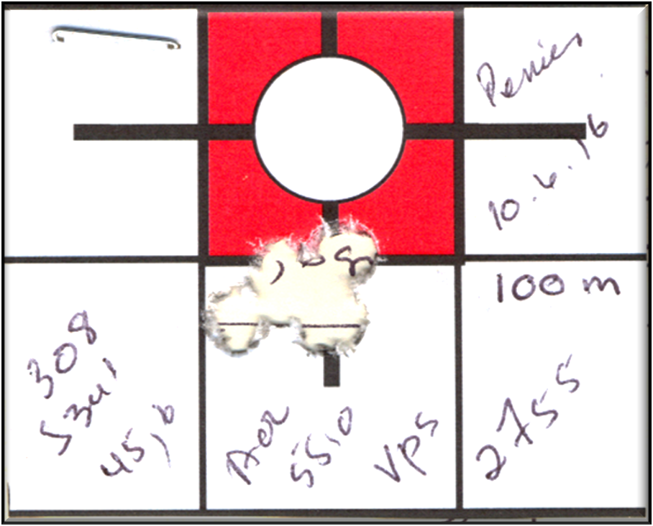

*Sub-MOA, four shot grouping of my 7,62 (308) at 100m.*

*The red square is 1 MOA @ 100m.*

*I keep on working on load development until all my rifles*

*can achieve this kind of grouping @ 100m and preferably @ 200m too.*

*The Enfield 7,62 (308) is, however, not set-up for accurate shots longer than 300m.*

* 1. The NHSA’s Falling Steel Plate Long-range Exercise in which I regularly compete (see Annexure A17), has the following specifications:

**200m to 600m RIFLE STEEL/RUBBER PLATE / GONG SHOOTING EXERCISE**

**---------------------------------------------------------------**

**FIREARMS PERMITTED: Only Centre-Fire Rifle Calibres**

**SHOOTING DISTANCE:** The shooting distance measured from the target to the edge of the firing line closest to the shooter is 200m, 300m, 400m, 500m or 600m.

**COURSES OF FIRE - 200m to 600m STATIONARY STEEL PLATE EXERCISE:** 5 shots at either

200m, 300m, 400m, 500m or 600m in your own time, shot on 5 individual falling steel plates set-up next to one another, and scored out of 50 points

**SCORING** - 10 points per dropped plate and 5 points per hit steel plate which did not fall over and 0 points per missed steel plate.

Plates to be spaced with at least 200mm gap between them, and set up on a flat / horizontal surface. **TARGETS: Stationary Falling plates:** shall be of square profile of maximum 200mm (w) x 200mm (h) x 10mm thick (b), with a support base extending at least 50mm and not more than 75mm behind the upright plate. 5% variation in any of above measurements are allowed.

**FIRING POSITION:** Any shooting position is valid; rifles may be rested on a bench, with the exception that rifle rests of which the front and the back are connected by a centre piece, may not be used.

**See NHSA website - https://natshoot.co.za/target-shooting/postal-shooting-exercises-and-targets/steel-plate- or-gong-shooting-exercises/rifle-steel-plate-gong**

* 1. I would like to better my own achievements over the longer distances, but it is clear it has to a certain extent, become an equipment related problem to solve, as my specific 7,62 is just not good enough to be really competitive at longer than 350m ranges. Hence the application for the 6,5 Creedmoor to be able to successfully participate in the NHSA’s long-range shooting discipline (see Annexure A18 and A19 as proof of my participation in the NHSA National Postal Target Shooting Competition in 2015 and 2016).
  2. As can be read off my NHSA verified Activities and Scores Report (Annexure A17), I am relatively active on the shooting range, either in target shooting or in load development to achieve pin-point accuracy with all my firearms. Something which is achievable when one reloads all your ammunition and visits the shooting range regularly (see Annexure A20).
  3. The 6,5 Creedmoor will, judging by all written reports and listening to other Creedmoor owners and long-distance shooters, definitely put me in a position to be really competitive in the NHSA’s long-range target shooting discipline.

## RELOADING OF RIFLE AMMUNITION

* 1. I have been reloading all my rifle calibres since 2007, with exception of the .22LR which is a rimfire cartridge which cannot be reloaded (see Annexure A21 which depicts sections of my reloading room).
  2. In discussions with fellow Creedmoor owners who also do their own reloading for purposes of precision accurate long-range shooting, it has become clear that the very high BC of the 140grain 6,5 (.264) bullets is the preferred bullet weight to reload over 41,5gr of S365 propellant; in Norma casings with Winchester magnum primers as preferred charge igniters. Fellow Creedmoor reloaders achieve speeds of up to 2,850 feet per second with this load configuration, and it is extremely accurate up to 1,100m as per their tests and their evidence.

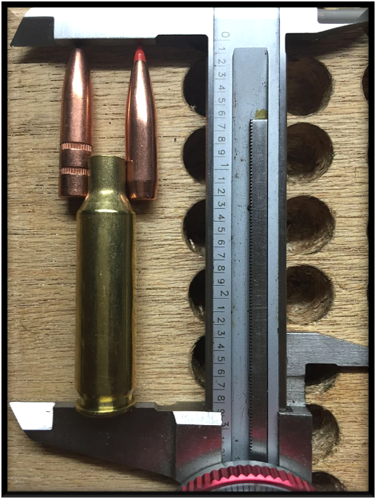Examples of long bullets of 6,5 calibre ascertaining very high BC figures

* 1. I shall start my reloading for the 6,5 Creedmoor at the above indicated load parameters, which will surely differ for my rifle, as each rifle has its own optimum load characteristics and preferred load configuration with a rifle specific overall cartridge length (bullet seating depth) for each individual rifle (albeit that load differences might be minute for my rifle).

## SAFE STORAGE

* 1. I attach a ***SAPS Correct Safe Storage Statement*** as Annexure A22 hereto.

## APPLICATION FOR RIFLE FOR DEDICATED SPORT SHOOTING

* 1. Against the above-mentioned background I request the central firearms registry to please grant me a licence for this Ruger 77, MKII rifle in the 6,5 Creedmoor calibre with serial number, xxxxxxxx, to be used for Dedicated Long-range Sport Shooting.

Sign motivation

***Xxxxxx xxxxxxx***